A century before coronavirus, Arizona was a haven for people fleeing another fearsome disease
Roger Naylor
Special for The Republic
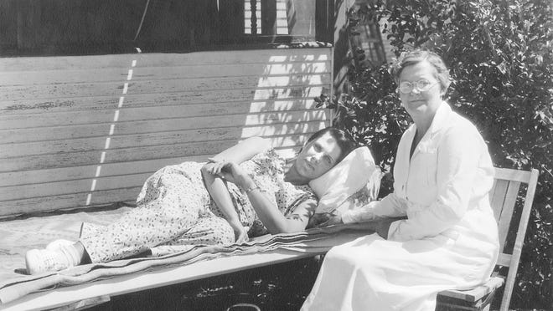

It’s a story that sounds eerily familiar.
A highly contagious disease ravages the lungs, causing a cough, fever, fatigue and night sweats. Widespread concern grows as the death toll mounts. While searching for a cure, social distancing is practiced.
Despite the contemporary parallels, this story dates back more than a century.
Tuberculosis, a potentially lethal bacterial disease, was the leading cause of death in Europe and the United States in the 1800s. It was known as the “White Plague” in Europe. In this country it was commonly called consumption, for how it consumed the body. Since there was no vaccine or medicine to combat the disease, doctors often encouraged patients to seek warm, dry climates to recover in or at least ease their symptoms.
In many cases, the Arizona Territory with its sun-kissed frontier — the very antithesis of the crowded industrialized cities of the East — became the destination of choice. And climate became one of the 5 Cs (along with copper, cotton, cattle and citrus) that formed the basis of Arizona’s early economy.
The influx of patients streaming west led to a population boom. Tuberculosis may have lured more people to Arizona than mining, ranching or commerce. Those increased numbers would eventually help Arizona achieve statehood in 1912.

Doc Holliday: AZ's most notable TB case

Arizona’s most notorious tubercular refugee was John Henry “Doc” Holliday, a dentist, gambler and gunfighter. Born in Georgia, he made his way west seeking a healthier climate. When wracking coughs forced Holliday to close his dental practice, he began to earn his living at card tables in saloons, including an extended hot streak on Prescott’s Whiskey Row.
More:Whiskey Row in Prescott: Arizona's most legendary block
When Wyatt and Virgil Earp departed for Tombstone, Holliday stayed in Prescott until the cards cooled off. He arrived in time to take part in the gunfight at the O.K. Corral.
Holliday was a mannerly Southern gentleman, or a mean-spirited drunk, or both, depending on which historic accounts you read. He survived numerous shootouts but couldn’t escape the disease he had contracted at a young age while caring for his ailing mother. In 1887, Holliday died at the age of 36 — without his boots on — in Glenwood Springs, Colorado. He had traveled there for the curative powers of the hot springs.
More:How the Gunfight at the O.K. Corral cemented Tombstone's place in history

A ranch becomes Oracle State Park
Neil Kannally was another Arizona health-seeker. He was not as well known as Doc Holliday but he left a greater impact on the state. In 1902 Kannally journeyed from his home in Illinois to a tuberculosis health resort set amid the rolling hills of Oracle, north of Tucson.
As he grew stronger, his brother Lee arrived and the two men purchased a 160-acre ranch. More siblings soon arrived — Molly, Vincent and the youngest, 7-year-old Lucile. The cattle business was good and the ranch continued to expand until it covered 50,000 acres.
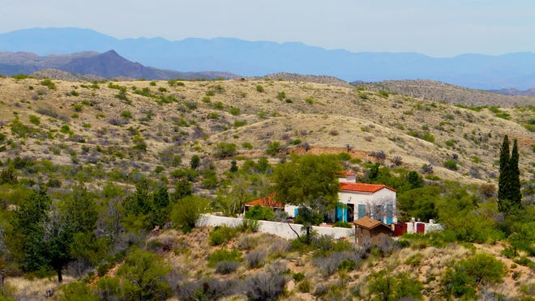

In 1929, the Kannallys began construction on a dramatic Mediterranean Revival-style home patterned after an Italianate villa. Over 2,600 square feet of space is spread across four levels. The house contains three spiral staircases, including one of natural stone. Towering windows overlook a European garden and rolling ranchland.
Today, the remnants of the Kannally ranch and lavish house are protected as Oracle State Park, a wildlife refuge and hiker’s paradise. Info: 520-896-2425, azstateparks.com/oracle.

The rise of Arizona sanatoriums
The health resort where Neil Kannally regained his vigor was saved from ruin and restored by the Oracle Historical Society. The Acadia Ranch Museum (520-896-9574, oraclehistoricalsociety.org) showcases the area’s past with exhibits on ranching and mining.
The Tuberculosis Room displays medical antiques and artifacts from the days when the ranch served as a sanatorium for “lungers.” Kannally is one of the patients who benefited from Arizona’s climate, surviving into his 70s. He died in 1951.
When Harold Nixon, older brother of future president Richard Nixon, became ill with tuberculosis in 1927, his mother took him to Prescott for the dry air. Several sanatoriums were set amid the pine forests. Richard, his father and brother would visit every few weeks.
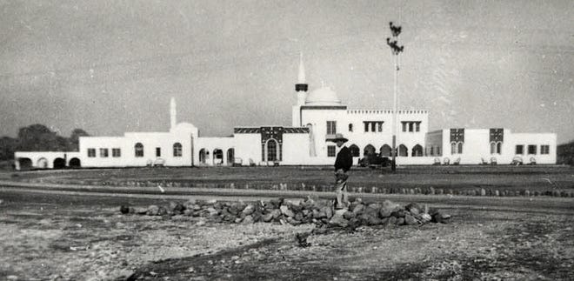
During the summers of ’28 and ’29, Richard stayed in Prescott, taking a series of jobs to help the family. He plucked chickens for a butcher and worked as a pool boy at the Hassayampa Country Club. He also was a barker for gaming booths at the Slippery Gulch carnival. In spite of the family’s efforts, Harold succumbed to tuberculosis in 1933.

Keeping patients isolated
In 1868, a French scientist proved that tuberculosis was not hereditary as long believed but was in fact contagious. Yet his findings were not completely accepted until 1882 when German microbiologist Robert Koch isolated the causative agent of the disease, a rod-shaped bacterium, tubercle bacillus.
Once it became clear the disease could spread through a cough or sneeze, isolation became part of the prescription in an effort to heal the sick while protecting the healthy. Sanatoriums began springing up in Arizona at the dawn of the 20th century.
Early facilities were designed almost as resorts staffed by doctors and nurses. They used different methods for treating patients but all therapy included plenty of fresh air, rest, wholesome food and exercise. While not a cure, sanatorium life did help strengthen many patients’ immune systems and reduced the risk they would infect others.

Sanatoriums in Phoenix and Tucson
Tucson in particular became a haven for sufferers of the disease. Local tourism campaigns heavily touted the restorative health benefits of the desert climate. At the turn of the 20th century, Tucson only had one public facility for consumptive patients, St. Mary’s Hospital and Sanatorium, along with a sprawling squatter’s camp known as Tentville. Other sanatoriums soon opened, drawing even more travelers.
According to the National Park Service, a 1913 federal public health survey noted that more than half the population of Tucson had emigrated west in search of a cure for consumption.
Sanatoriums could also be found in and around Phoenix. Bethany Home, on the road that still bears its name, was a tuberculosis sanatorium run by a religious organization in the early 1900s.
Desmount Sanatorium opened in 1920 in Cave Creek, modest cabins once located where the Buffalo Chip Saloon now sits. The last intact tubercular cabin in Arizona (from the Desmount) was placed on the National Register of Historic Places. It can be seen at the Cave Creek Museum. Info: 480-488-2764, www.cavecreekmuseum.org.
Folks who could not afford sanatoriums had to survive the best they could. Some health seekers moved to Sunnyslope, which was still roadless desert back then. They lived in tents, shacks and small cottages. It was a hard existence but one made easier by their neighbors. Marguerite Culley, a practical nurse, and Elizabeth Beatty, a retired secretary, began making deliveries of food, medicine and schoolbooks to the sick. For their tireless efforts, they became known as the “Angels of the Desert.”
Eventually, the tuberculosis epidemic came to an end in the 1940s when antibiotics were developed to treat the disease once so feared it earned the sobriquet “Captain of all these men of death.”
Find the reporter at www.rogernaylor.com. Or follow him on Facebook at www.facebook.com/RogerNaylorinAZ or Twitter @AZRogerNaylor.

https://www.azcentral.com/story/travel/arizona/road-trips/2020/05/11/arizona-tuberculosis-history-sunnyslope-sanatoriums-doc-holliday/3101543001/

